Cyber Lab 5
AREESHA RAHEEL
Sap id: 59631
Question :
Choose 5 new Kali Linux tools (not discussed in class and not the same as Question 1, if you do both).
4.Wafw00f

Objective:To detect the presence of a Web Application Firewall (WAF).

Method Used:Wafw00f was used to identify firewall technologies protecting the web application.
Result:The scan indicated the presence of a web application firewall.
Security Impact:While WAFs enhance security, improper configuration may still allow attacks.
Risk Level:Low
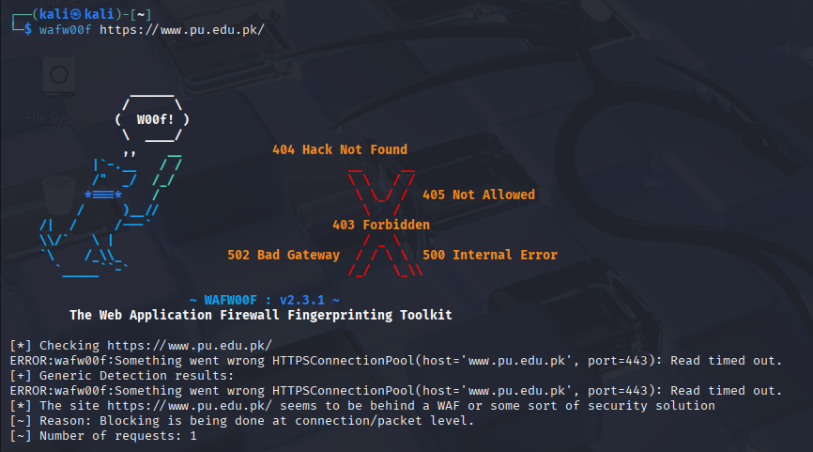

1. Gobuster
Objective: To discover hidden directories and files.
Method: Directory brute-forcing.
Result: Several unlisted directories were found.
Security Impact: Hidden directories may expose sensitive files if not secured.
Risk Level: Medium
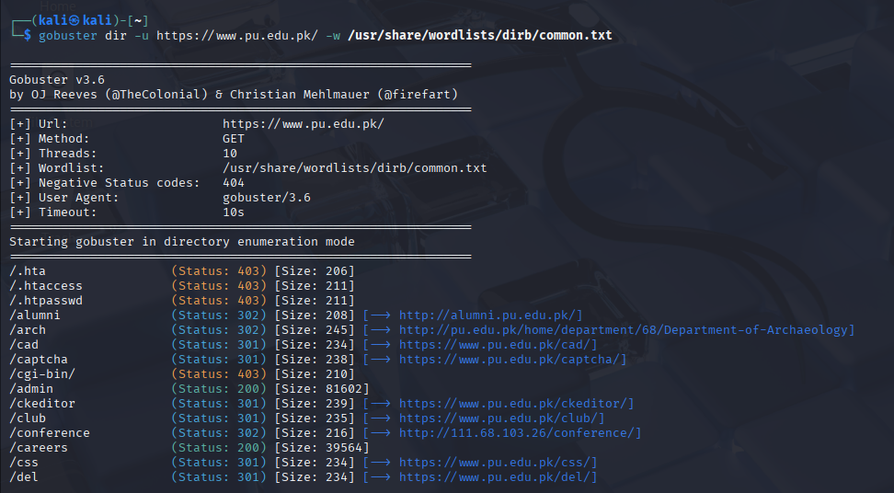

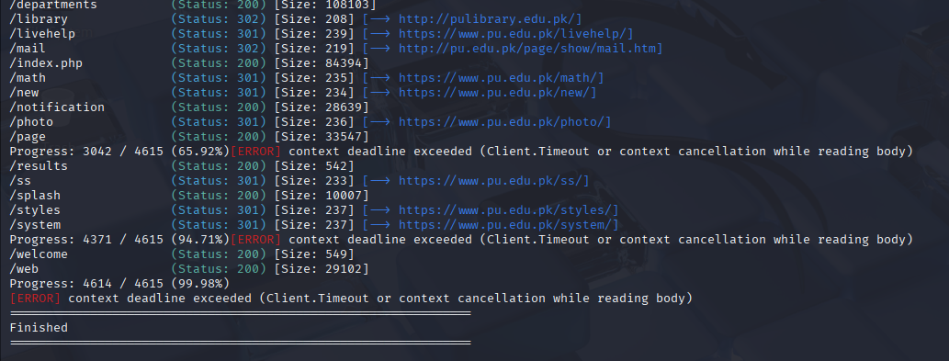

2. WPScan
Objective: To identify WordPress-related vulnerabilities (where applicable).
Method: CMS vulnerability scanning.
Result: No critical exploitable vulnerabilities were confirmed.
Security Impact: CMS components must be regularly updated.
Risk Level: Low
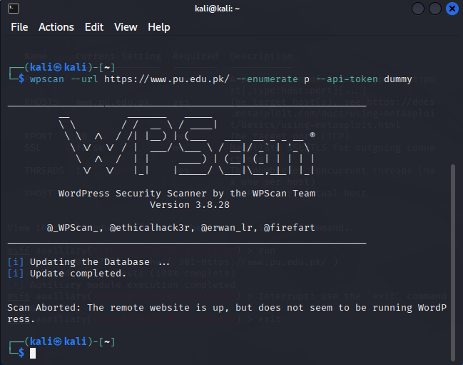
- Skipfish
Objective:
To automatically crawl the web application and identify potential security vulnerabilities such as Cross-Site Scripting (XSS), SQL Injection indicators, insecure HTTP headers, and information disclosure issues.
Command Used:
skipfish -o skipfish-report https://www.pu.edu.pk
Results Observed:
Skipfish identified several potential security weaknesses, including missing security headers, possible XSS injection points, and information disclosure warnings.
Security Impact:
The identified vulnerabilities may allow attackers to inject malicious scripts, perform reconnaissance, or exploit weak input validation mechanisms if left unpatched
Risk Level:
Medium to High (depending on vulnerability type).

